# **P.S.R.R COLLEGE OF ENGINEERING**

**SIVAKASI - 626140**

**VIRUDHUNAGAR DISTRICT**

*DEPARTMENT*

*OF*

*COMPUTER SCIENCE AND ENGINEERING*



SB8067

Salesforce Developer

Team Members

Arunkumar A (952022104006)

Thulasi Rajan M (952022104054)

Bharat Kannan (952022104008)

Ganeshkumar A (952022104012)

# **Jewellery Inventory System**

**Executive Summary & Project Overview**

This document outlines the design and configuration of the **Jewellery Inventory System**, a custom Salesforce application developed to streamline the data management, inventory tracking, customer orders, and billing processes for a Goldsmith organization.

The solution utilizes **Custom Objects**, declarative automation (Flows, Validation Rules), Apex code (Trigger/Handler), and a tailored **Security Model** to provide an efficient and structured platform for the business owner and workers. The system’s core purpose is to organize and leverage critical information, enabling streamlined workflows, personalized reporting, and enhanced user experiences specific to the jewelry business.

* **App Name:** Jewellery Inventory System
* **Description:** Elevate your look with elegance
* **Navigation Style:** Console Navigation
* **Status:** Initial Configuration Complete

**Objectives**

1. To automate the management of jewellery stock and supplier data.

2. To provide real-time monitoring of product availability and sales trends.

3. To improve operational efficiency through process automation using Salesforce Flows and Triggers.

4. To enable detailed reporting and visualization using Salesforce Dashboards

**Requirement Analysis**

The system requires the following Salesforce components: - Custom Objects: Product, Supplier, Inventory, Sales Transaction, Employee.

Relationships: Lookup and Master-Detail relationships between objects.

User Roles: Admin, Manager, and Staff with appropriate profile permissions.

Validation Rules: To ensure data accuracy and integrity during record creation

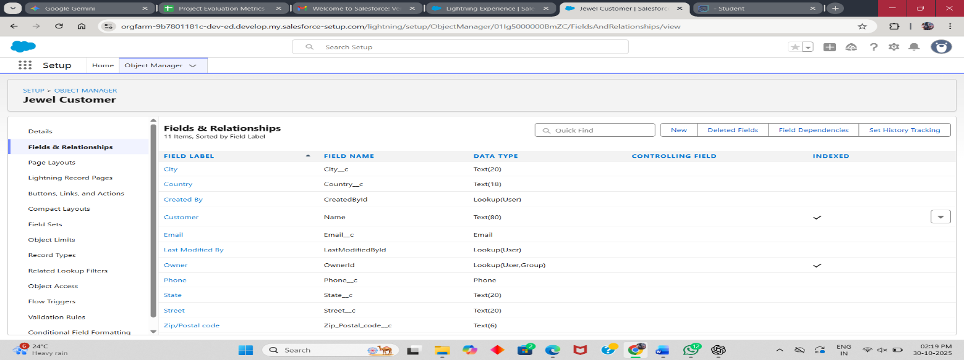

**System Design**

The design includes an Entity-Relationship (ER) Diagram and Flow Diagram representing object relationships, process automation, and business logic

**Implementation Details**

The implementation involves creating custom objects, fields, relationships, validation rules, and triggers within Salesforce. Additionally, profiles and roles are configured to control access

**Data Model Design**

The solution is built upon a set of **Custom Objects** to store business-specific data, replacing legacy methods like spreadsheets.

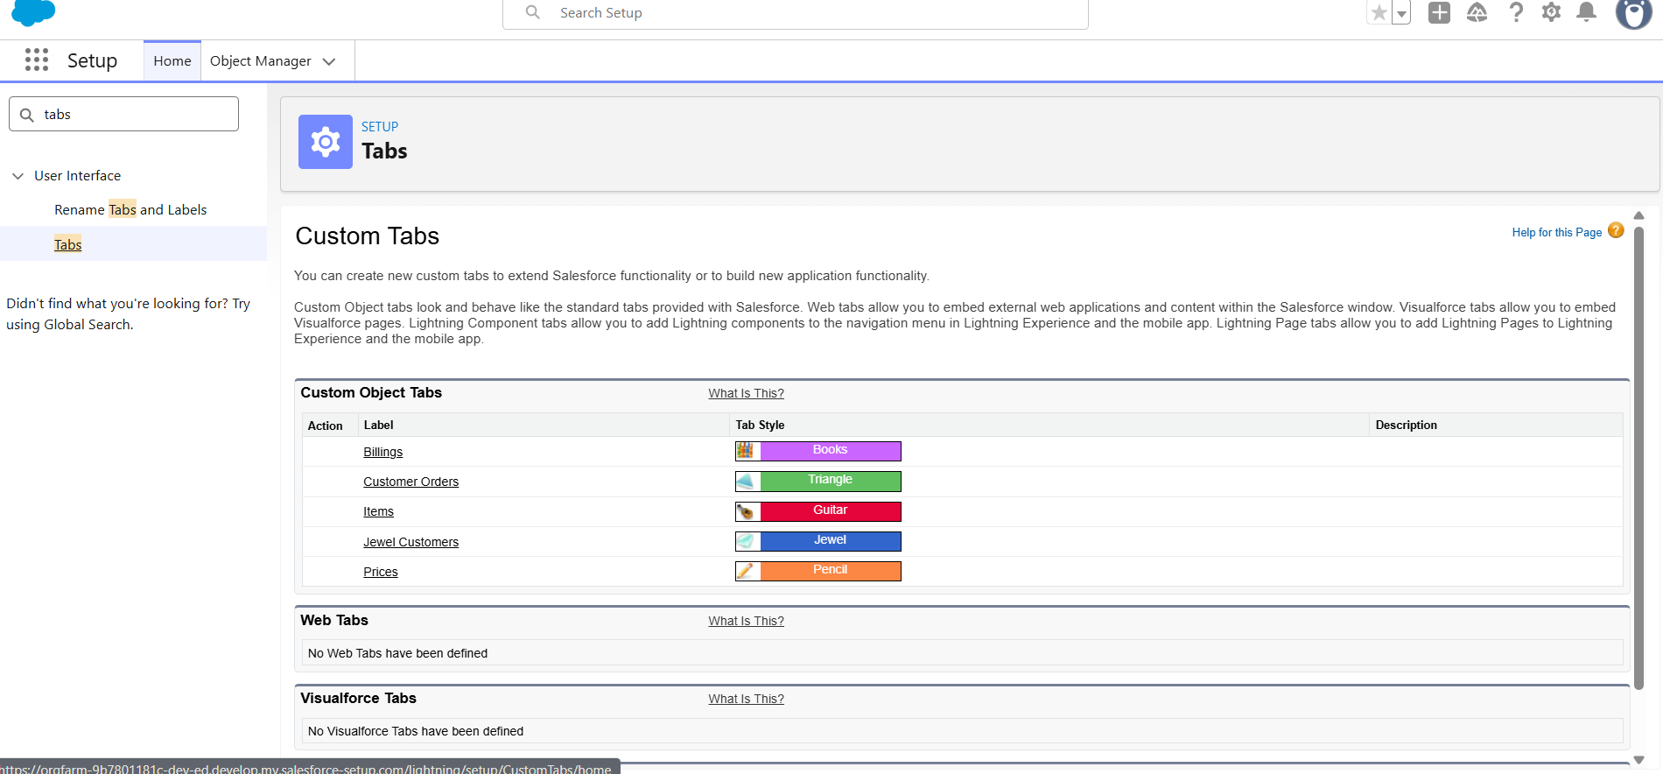

**Custom Objects Created**

| **Object Label** | **Plural Label** | **Record Name Format** | **Purpose** |
| --- | --- | --- | --- |
| **Jewel Customer** | Jewel Customers | Customer Name (Text) | Store and manage customer information. |
| **Item** | Items | Item-{00} (Auto Number, Start: 1) | Manage inventory of gold and silver items. |
| **Customer Order** | Customer Orders | CO-{00} (Auto Number, Start: 1) | Track customer orders. |
| **Price** | Prices | P-{00} (Auto Number, Start: 1) | Store current market prices for materials. |
| **Billing** | Billings | B-{00} (Auto Number, Start: 1) | Handle billing and payment records. |

**Object Relationships**

| **Child Object** | **Relationship Type** | **Field Label** | **Parent Object** | **Description** |
| --- | --- | --- | --- | --- |
| **Customer Order** | Lookup | Customer | Jewel Customer | Links an order to the specific customer. |
| **Customer Order** | Master-Detail | Item | Item | Links an order to the specific item being worked on. |
| **Item** | Lookup | Prices | Price | Links an item to its price record for formula calculations. |
| **Item** | Lookup | Customer Name | Jewel Customer | Links the item record to the customer who owns it. |
| **Billing** | Lookup | Item | Item | Links a billing record to the item it pertains to. |

**Key Custom Fields and Formulas (Summary)**

Key custom fields, including contact details and core inventory metrics, were created using various data types (Text, Phone, Email, Number, Currency, Picklist). The system includes complex Formula Fields on the Item and Billing objects to automatically calculate critical business values:

* Item Formulas: Purity Gold Price, Total Weight (Net metal weight), Amount (Base metal cost), KDM, and Making Charges.
* Billing Formulas: Pulls related item data (Ornament, Weight, Amount) and calculates the Total Amount.

**Security and Sharing Model**

**Profiles**

A profile is a group/collection of settings and permissions that define what a user can do in salesforce. Profile controls “Object permissions, Field permissions, User permissions, Tab settings, App settings, Apex class access, Visualforce page access, Page layouts, Record Types, Login hours & Login IP ranges.

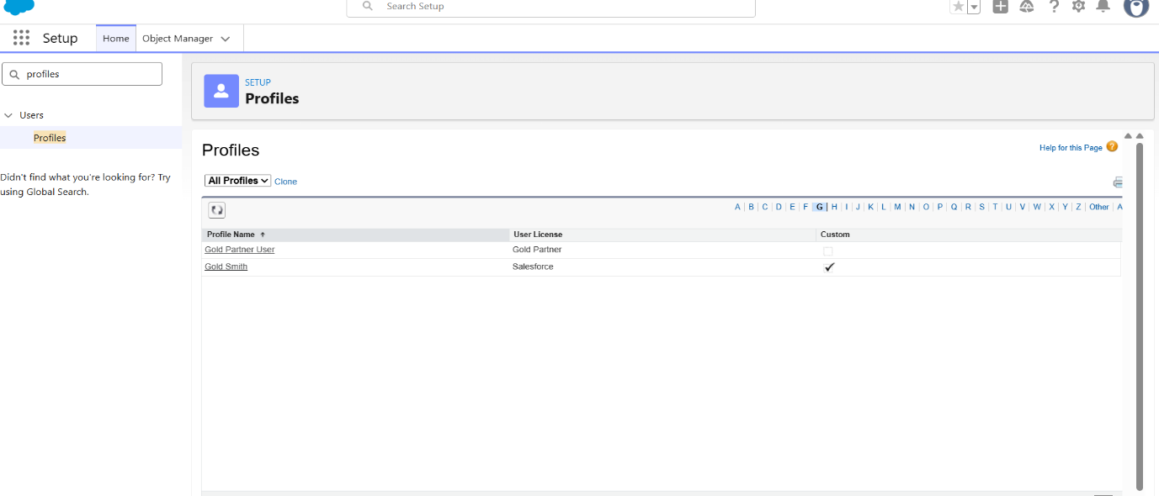

**Roles**

A role in Salesforce defines a user's visibility access at the record level. Roles may be used to specify the types of access that people in your Salesforce organisation can have to data. Simply put, it describes what a user could see within the Salesforce organisation.

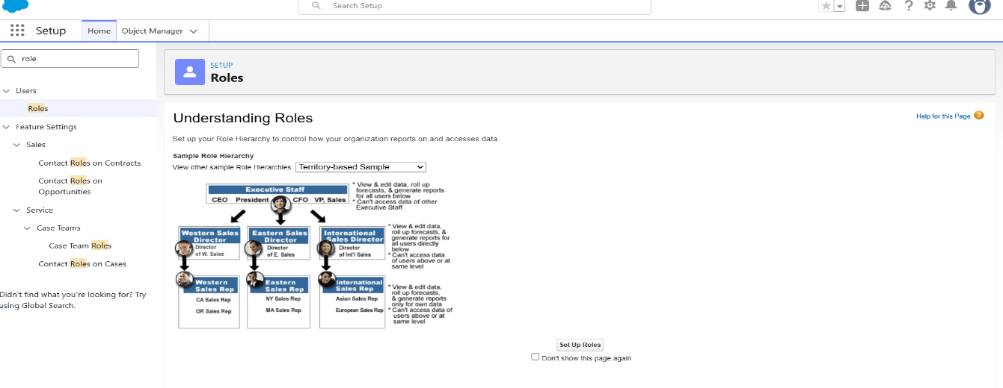

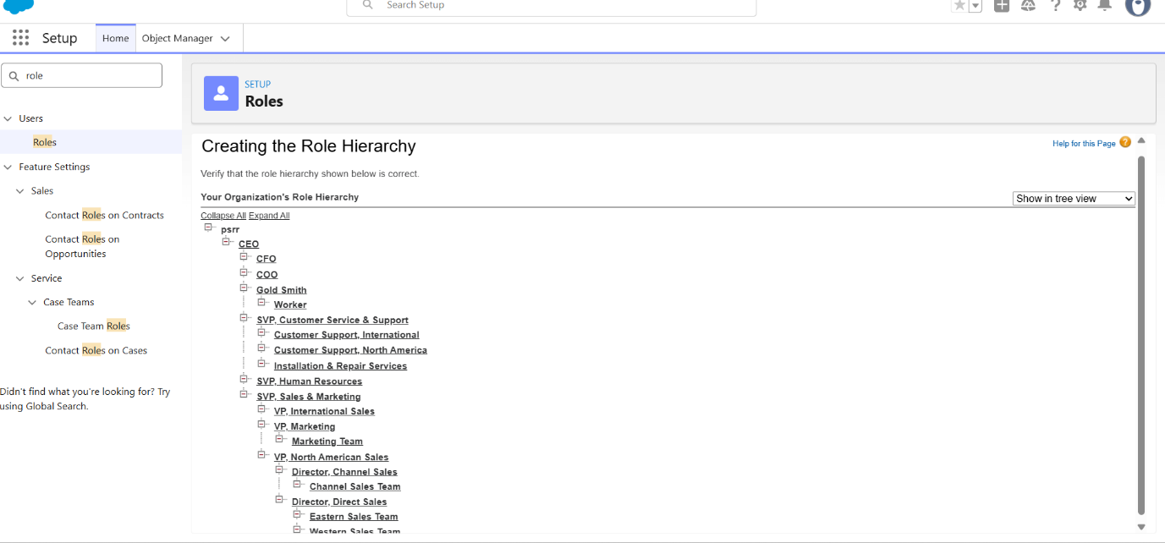

| **Role** | **Profile (Cloned From)** | **Purpose** |
| --- | --- | --- |
| **Gold Smith** | Gold Smith (System Administrator) | Owner/Lead worker with full access to all custom objects. |
| **Worker** | Worker (Salesforce Platform User) | Standard worker with restricted access to Item, Price, and Customer Order objects. |

**Permission Sets**

A standard permission set consists of a group of common permissions for a particular feature associated with a permission set licence. Using a standard permission set saves you time and facilitates administration because you don't need to create the custom permission set.

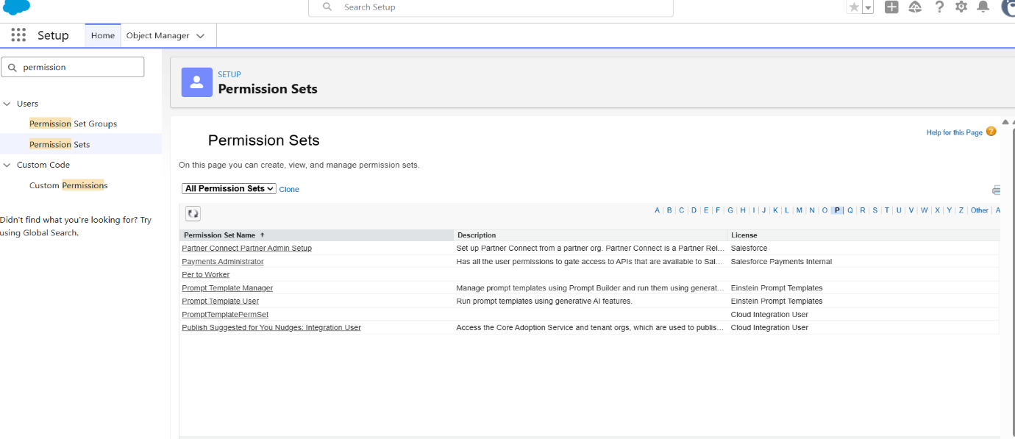

| **Permission Set Label** | **Object** | **Record Type Access** | **Object Permissions** |
| --- | --- | --- | --- |
| **Per to Worker** | Item | Gold, Silver | Read, Edit, Create |

**Automation and Business Logic**

**Validation Rules**

Validation rules enforce data quality and process consistency on the Jewel Customer and Item objects.

Creating the validation rule for Postal Code field in Jewel Customer object

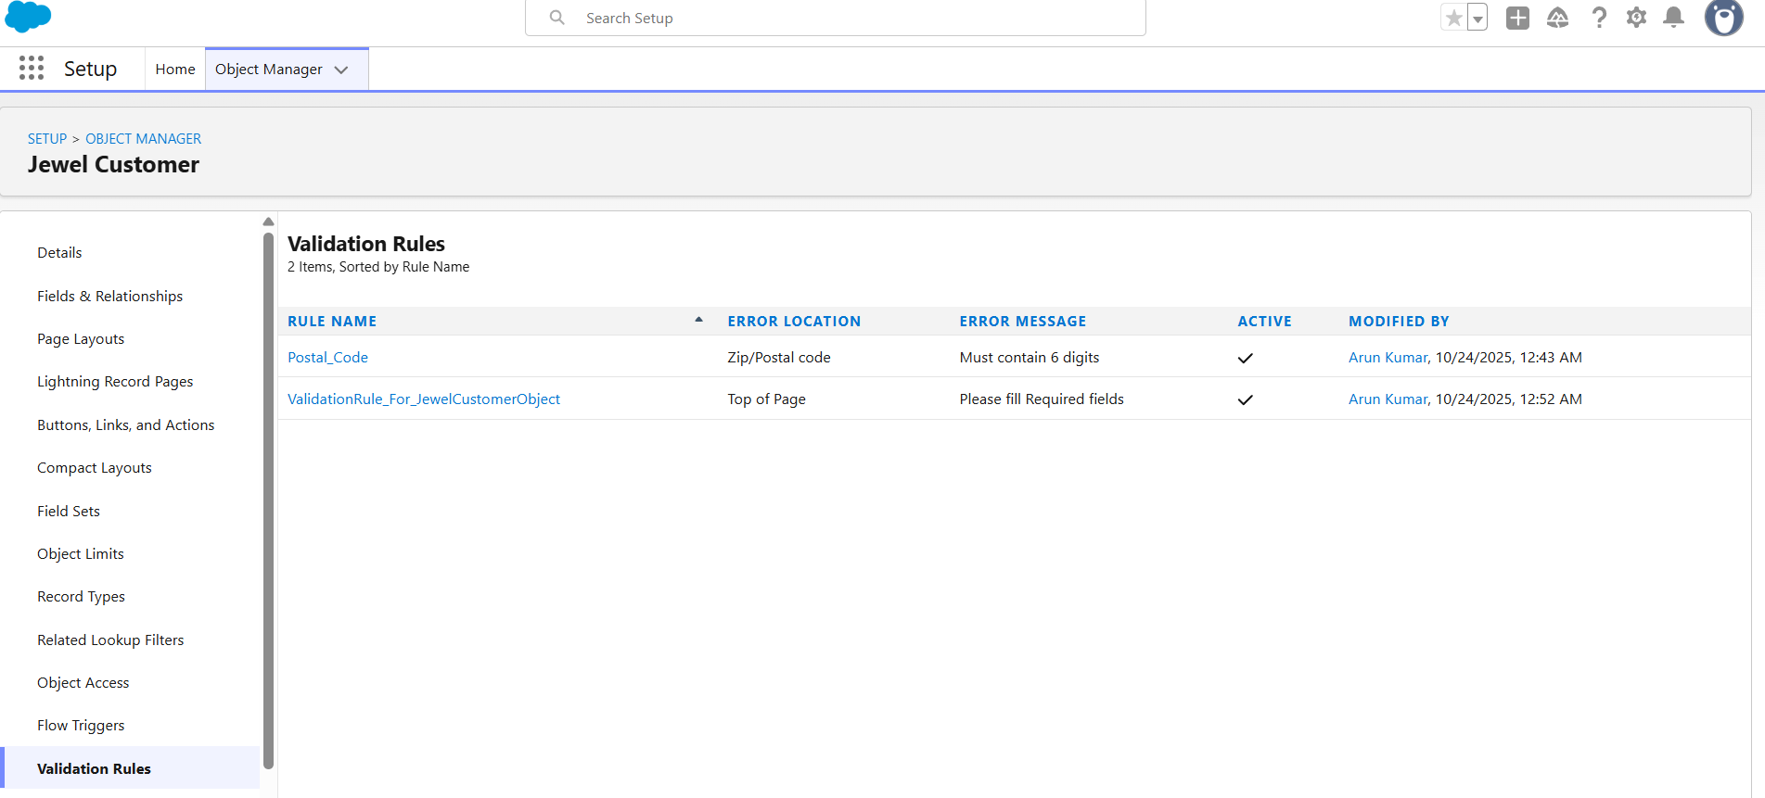

| **Object** | **Rule Name Example** | **Rationale** |
| --- | --- | --- |
| **Jewel Customer** | Postal Code | Ensures Zip/Postal code is exactly 6 digits and numeric. |
| **Jewel Customer** | Required Fields | Ensures all core fields (City, Country, Phone, State, Street) are populated before saving. |
| **Item** | ValidationRule For Item | Ensures all necessary item metrics and pricing fields are filled. |

**Apex Trigger and Handler (Billing__c)**

| **Component** | **Object** | **Event** | **Logic Summary** |
| --- | --- | --- | --- |
| **UpdatePaidAmountTrigger** | **Billing__c** | **before insert, before update** | **Aggregates payments: On insert, sets Paid_Amount__c equal to Paying_Amount__c. On update, it adds the new Paying_Amount__c to the existing Paid_Amount__c.** |

**Record-Triggered Flow (Email Notification)**

A flow is triggered to send an email notification to the customer upon the creation or update of a Billing record.

| **Object** | **Trigger Event** | **Optimization** | **Action** |
| --- | --- | --- | --- |
| **Billing__c** | Created or Updated | Actions and Related Records | Sends an email notice to the Jewel Customer ({!$Record.Item__r.Customer_Name__r.Email__c}) with item details (Type, Ornament, Weight, Amount). |

**Field Dependency**

* Controlling Field: Priority on the Item object.
* Dependent Field: Expected Days of Return on the Item object.
* Purpose: To control the available 'Expected Days of Return' options based on the urgency selected in the 'Priority' field.

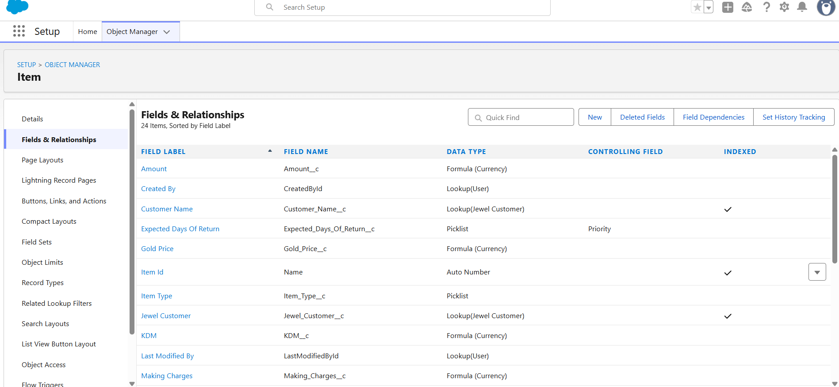

**User Interface and Experience**

**Custom Tabs**

Custom Tabs were created for all custom objects to ensure users can interact with records directly from the application's navigation bar.

* Jewel Customer
* Item
* Customer Order
* Price
* Billing

**Record Types and Page Layouts (Item Object)**

Two Record Types were created on the Item object to manage distinct page layouts for Gold and Silver items, simplifying the user experience by showing only relevant fields.

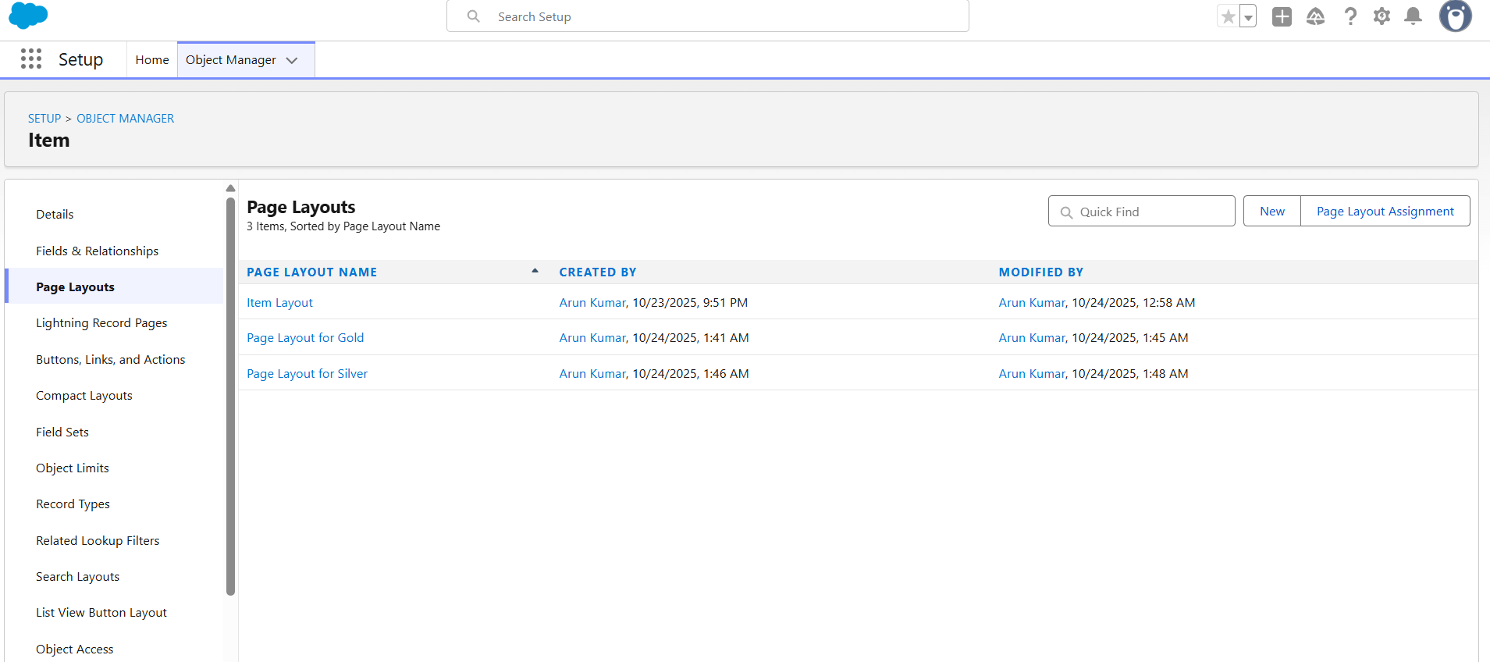

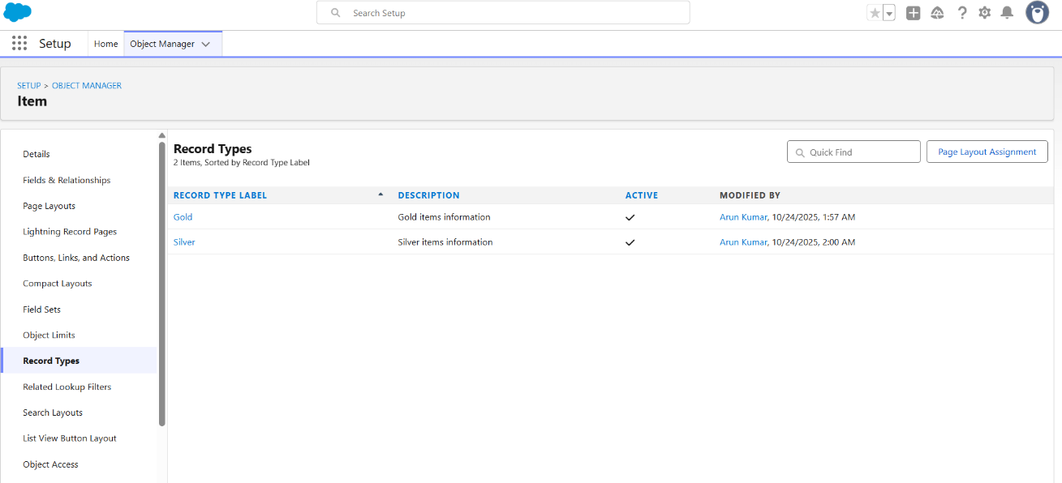

| **Record Type Label** | **Page Layout** | **Profiles Assigned** | **Rationale** |
| --- | --- | --- | --- |
| **Gold** | Page Layout for Gold | Gold Smith, Worker, System Administrator | Removes Silver-related fields. |
| **Silver** | Page Layout for Silver | Gold Smith, Worker, System Administrator | Removes Gold-related fields. |

**Reporting and Analytics**

The system includes reports and dashboards to provide business intelligence on inventory and financial transactions.

**Reports**

| **Report Type** | **Purpose** |
| --- | --- |
| **Item with Billings** | To see a combined view of inventory items and their associated billing/payment status. |
| **Billings with item and Customer order** | To analyze the full transaction lifecycle from item creation to order status and final billing. |

**Dashboards**

Multiple dashboards were created to visually represent the data from the reports, providing a high-level, at-a-glance view of the business performance

**Flows**

This flow is designed to automatically notify a customer via email when a billing record is created or updated, providing them with key details about their purchased item.

**Flow Details**

| **Setting** | **Value** |
| --- | --- |
| **Type** | Record-Triggered Flow |
| **Object** | Billing__c |
| **Trigger Flow When** | A record is **Created or Updated** |
| **Optimize the flow for** | **Actions and Related Records** |
| **Label** | (Given during Save, e.g., Billing Email Notice) |
| **Status** | **Active** |

**Resources Created**

**Text Template:** Email_body

This resource builds the rich-text content of the email, dynamically merging data from the new or updated Billing record and its related Item and Jewel Customer records.

| **Field** | **Value/Merge Field** | **Description** |
| --- | --- | --- |
| **Customer Name** | {!$Record.Item__r.Customer_Name__r.Name} | Customer name pulled from the Item's related Jewel Customer. |
| **Item Type** | {!$Record.Item__r.Item_Type__c} | Type of material (Gold/Silver) from the related Item. |
| **Ornament** | {!$Record.Ornament__c} | Ornament description from the Billing record (which is a Formula field pulling from the Item). |
| **Weight** | {!$Record.Weight__c} | Total net weight of the item from the Billing record. |
| **Amount** | {!$Record.Amount__c} | Base metal cost of the item from the Billing record. |

**Body Syntax (Plain Text View):**

Customer Name: {!$Record.Item__r.Customer_Name__r.Name item

Item Type: {!$Record.Item__r.Item_Type__c}

Ornament: {!$Record.Ornament__c}

Weight: {!$Record.Weight__c}grams Amount: {!$Record.Amount__c}

**Elements and Logic**

**Action:** Send Email (notice)

This element is responsible for dispatching the email using the Text Template created above.

| **Setting** | **Value** | **Description** |
| --- | --- | --- |
| **Label** | notice | The name of the action element. |
| **Subject** | Welcome to Jewelry Inventory System | The static subject line for the email. |
| **Body** | {!Email_body} | The Text Template resource containing the email content. |
| **Recipient Address List** | {!$Record.Item__r.Customer_Name__r.Email__c} | The recipient's email address, dynamically retrieved from the **Jewel Customer** record (via the Item lookup on the Billing object). |

**Conclusion**

The Jewellery Inventory System successfully demonstrates Salesforce capabilities in custom object management, automation, and reporting. It provides a scalable and maintainable solution for inventory and sales management within the jewellery industry.